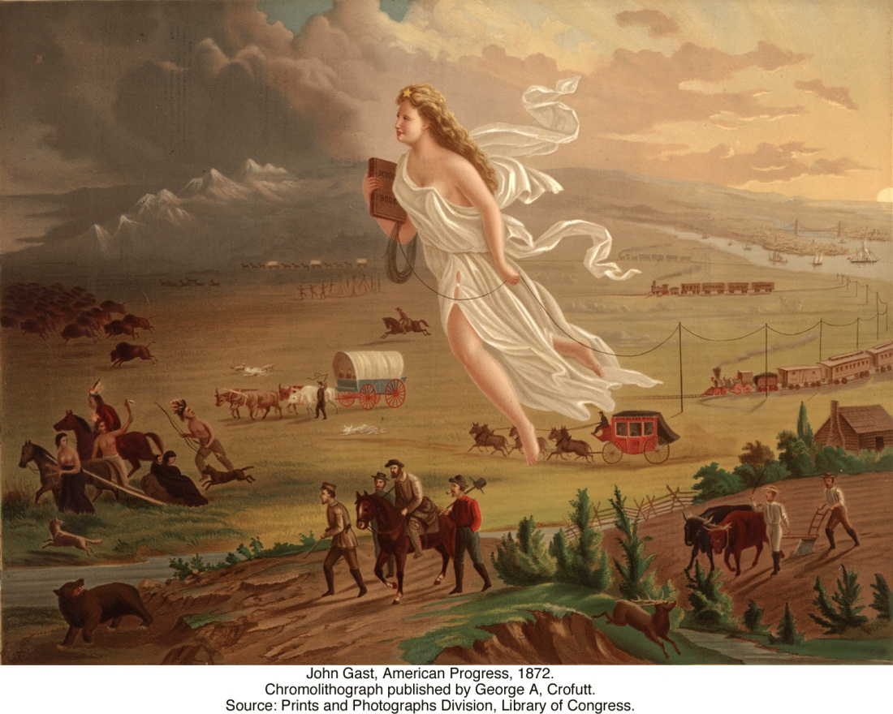

Historical Art Analysis:

- What are the two groups of people in this painting?

- What are the two categories of Animals in the painting?

Continued

- What physical features are in the background?

- What other objects appear in the painting?

- What are the activities in which are some of the people engaged?

- In which direction does the movement flow in the painting?

- Describe the artist’s use of light in the painting?

Continued
- What large figure appears in the center of the painting? What do think this figure is supposed to represent?

- What message do you think the artist is trying to communicate?
  - Describe completely
  - List the details that are most important to that message.

