Key Decision 1803: Jefferson and the Louisiana Territory
It is 1803. Thomas Jefferson is the President of the United States.
Jefferson believes that farming and landownership are essential ingredients for a strong and democratic republic. He believes that farmers who own their own land are truly free and form the bedrock of a free society. He also believes that an agriculturally based economy will lead to greater equality and liberty among Americans.
But Jefferson sees a problem on the horizon because of two facts. First, every 16 years the population of the United States has doubled. Second, the United States extends westward only to the Mississippi River. Jefferson estimates that because of the current rate of population growth, all of America’s land will be claimed and farmed within 50-70 years. He fears that after that time his dream of an agricultural republic will start to fade as millions upon millions of future Americans will have no choice to but to seek work in factories and in large cities.
There is another and more immediate problem facing the President. Currently more and more Americans are moving west of the Appalachian Mountains, and are beginning to farm in the Ohio and Mississippi River Valleys. To prosper these farmers will need to get their crops to markets in America’s cities and population centers. The primary transportation route that these farmers will rely on for shipping their crops is the Mississippi River. But, all traffic on the Mississippi River flows through the city of New Orleans, which is owned and controlled by the French. New Orleans functions like a toll booth on the river, allowing the French to charge fees for use of the river, or to deny passage. The French also control the lands along western bank of the Mississippi River, which puts them in a position to dominate the river’s use. The Spanish used to control New Orleans and surrounding territories, but they have recently ceded (turned over) these to the French. When the Spanish controlled traffic on the Mississippi it was sometimes difficult or impossible for American traders to use the river. Jefferson fears that now the French may charge high fees for passage on the river, or even deny Americans use of the waterway altogether. This would be disastrous for western farmers and the agricultural economy of the United States.
Fearful that France might deny Americans navigation rights to the Mississippi, and use of the port of New Orleans, Jefferson sent Robert Livingston and James Monroe to Paris to negotiate for the purchase of the city of New Orleans which would secure control of the river for the United States. To Jefferson’s surprise the French leader, Napoleon Bonaparte, is looking to sell New Orleans and the vast territory of Louisiana (over 800,000 square miles) which lies to the west of the Mississippi River… and all for only $15 million dollars. That’s less than 3 cents an acre.
This is a dream come true for Jefferson, but there is one problem stalling the deal. President Jefferson is a strict interpreter of the Constitution, which means that he believes that the powers of the government (including the President) are strictly limited to what is explicitly stated in the Constitution. Jefferson’s dilemma is that the Constitution does not give the President the power or authority to buy land. Jefferson desperately wants to buy Louisiana from the French, but at the same his hands are tied by his own interpretation of the constitution.
You are one of Jefferson’s closest advisors, and he needs your help to resolve this dilemma.
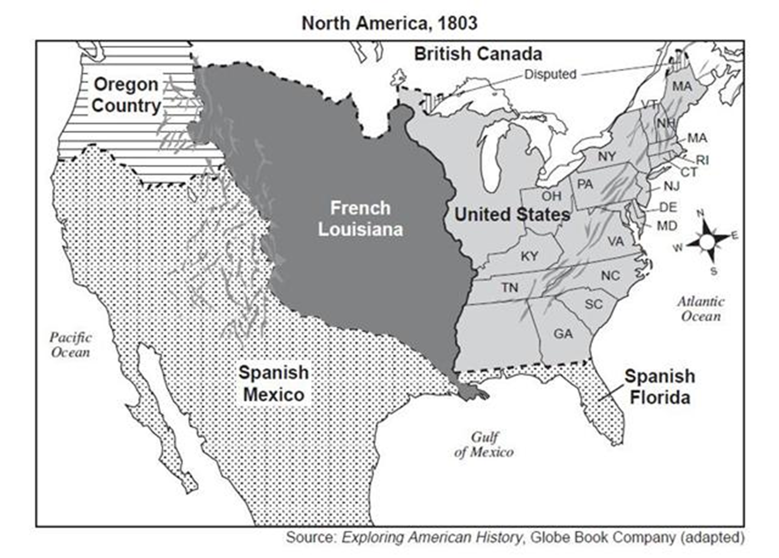
Task #1: Comprehension Questions & Top-Down Web

- What is Jefferson’s vision for the future of the United States?

- Why is this future in doubt?

- What nation controls New Orleans and the Louisiana Territory, and why is this a problem for Jefferson and Americans in the west?

- Why is purchasing the Louisiana Territory important to Jefferson and his vision for America’s future?

*Answer this by filling-out the attached top-down web

- How does Jefferson interpret the Constitution, and why is this a problem now that he has the opportunity to purchase Louisiana from the French?

Task #2: Advise the President

Your Role: You are an advisor the President Thomas Jefferson in 1803.

Your task: Find a way for President Jefferson to purchase the Louisiana Territory, while sticking to the powers given to the President in Article II of the Constitution.

- Pick through the wording of your copy of Article II, Sections 1-3 of the U.S. Constitution (attached). This is the part of the Constitution that outlines the powers and responsibilities of the President.

- Underline or highlight anything that could be interpreted in a way that would give the President the authority to negotiate with France to buy the Louisiana Territory.

- Write a short letter/memo to your boss, President Jefferson, telling him a “constitutional” way for him to buy the Louisiana Territory.

  - In your letter be sure to include a short quote from Article II Sections 1, 2, or 3 that you found that you believe grants the President the power to make a deal for with France for Louisiana.

  - In your own words, explain how this section gives him the authority to obtain Louisiana.

  - Write no less than 5 lines

*Complete this on a separate sheet of white-lined paper

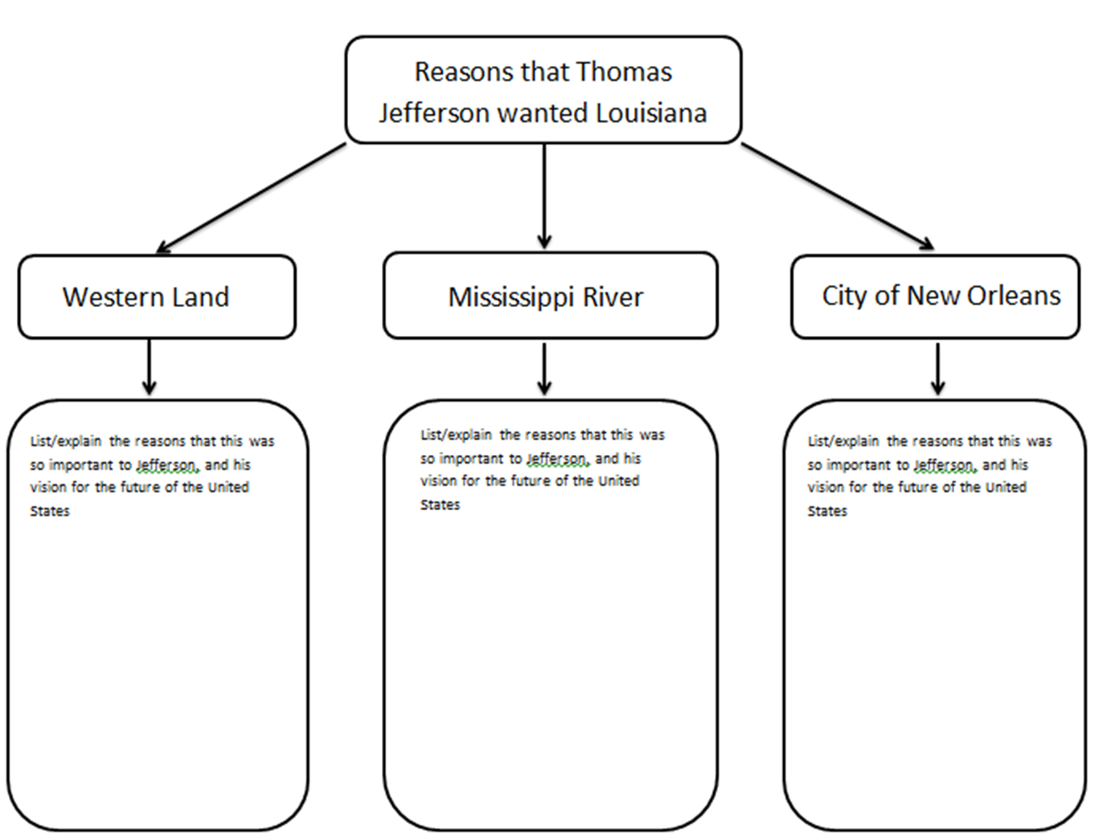
Article II of the United States Constitution (The Powers of President)
Section 1:
The executive power shall be vested in a President of the United States of America…
Section 2:
The President shall be commander in chief of the Army and Navy of the United States, and of the militia of the several states, when called into the actual service of the United States; he may require the opinion, in writing, of the principal officer in each of the executive departments, upon any subject relating to the duties of their respective offices, and he shall have power to grant reprieves and pardons for offenses against the United States, except in cases of impeachment.
He shall have power, by and with the advice and consent of the Senate, to make treaties, provided two thirds of the Senators present concur; and he shall nominate, and by and with the advice and consent of the Senate, shall appoint ambassadors, other public ministers and consuls, judges of the Supreme Court, and all other officers of the United States, whose appointments are not herein otherwise provided for, and which shall be established by law: but the Congress may by law vest the appointment of such inferior officers, as they think proper, in the President alone, in the courts of law, or in the heads of departments.
The President shall have power to fill up all vacancies that may happen during the recess of the Senate, by granting commissions which shall expire at the end of their next session.
Section 3:
He shall from time to time give to the Congress information of the state of the union, and recommend to their consideration such measures as he shall judge necessary and expedient; he may, on extraordinary occasions, convene both Houses, or either of them, and in case of disagreement between them, with respect to the time of adjournment, he may adjourn them to such time as he shall think proper; he shall receive ambassadors and other public ministers; he shall take care that the laws be faithfully executed, and shall commission all the officers of the United States.

