Name_________________________ Per _______
Farm to Factory: A Primary Source Archive
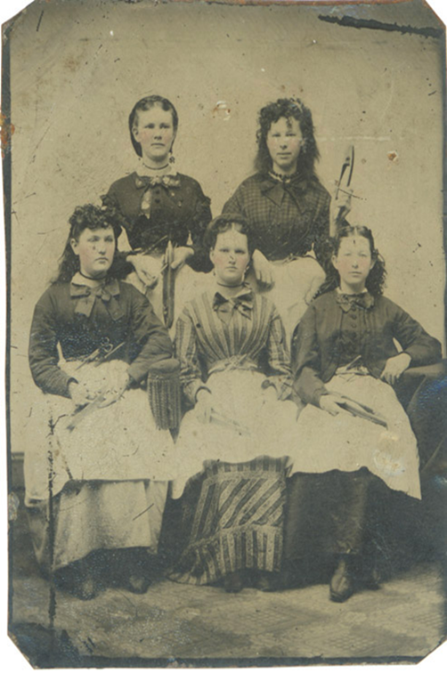
Documents:
- Adeleen Blake letter

- Mary Paul Letter

- Harriet Robinson autobiography excerpt

- Harriet Farley Letter

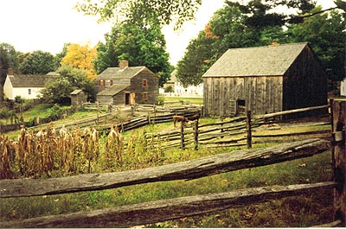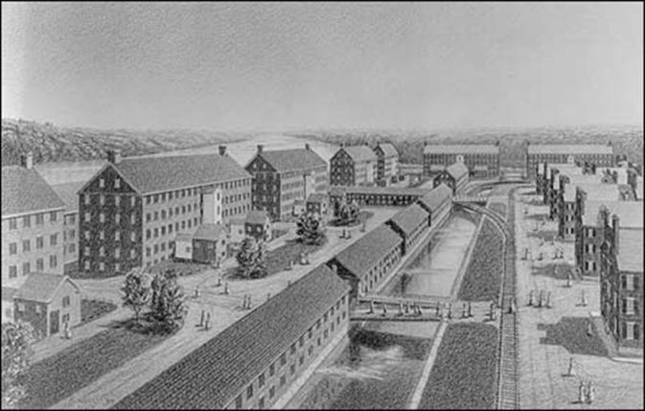

Document 1
Mill Girl Adeleen Blake
1840 Letter to “Cousin Hannah”

My dearest Hannah,
Please forgive me for not writing you since I left home. Never in my sixteen years has the time seemed to pass so swiftly. My days are so very long and I am so fatigued [tired] by supper, that writing seems like an added burden at the end of the day. I long for nothing more than sleep after a day of labor, but since I am the oldest and the first to leave home, I feel it my duty to write to my parents once or twice each week.
…It is true that work in the mill is laborious [hard], but I feel so proud that I am now able support myself. I send a portion of my wages home each month to help with expenses. Charlie [brother] will be off to school [college] soon enough, and I will have the satisfaction of knowing that my wages will help him continue his studies…
… I have managed to save some money toward my dowry. Father is of humble means and is unable to help much toward that expense.
…There are a great variety of shops in Lowell, and I do allow myself the purchase of an occasional luxury… a new comb or a ribbon for my hair…

___________________________________________________________________________
*dowry- an amount of money or property given in some societies by a bride's family to her bridegroom or his family when she marries

Document 2
Mill Girl Mary Paul (Letters to her father)

Sept. 13th 1845 [Sent from Woodstock, VT]
Dear Father
…I want you to consent to let me go to Lowell if you can. I think it would be much better for me than to stay about here. I could earn more to begin with than I can any where about here. I am in need of clothes which I cannot get if I stay about here and for that reason I want to go to Lowell or some other place. We all think if I could go with some steady girl that I might do well. I want you to think of it and make up your mind. Mercy Jane Griffith is going to start in four or five weeks. Aunt Miller and Aunt Sarah think it would be a good chance for me to go if you would consent-which I want you to do if possible. I want to see you and talk with you about it.
Mary
Nov 20th 1845 [Sent from Lowell, MA]
Dear Father
An opportunity now presents itself which I improve in writing to you. I started for this place at the time I talked of which was Thursday. I left Whitneys at nine o'clock stopped at Windsor at 12 and staid till 3 and started again. Did not stop again for any length of time till we arrived at Lowell. Went to a boarding house and staid until Monday night.
… We found a place in a spinning room and the next morning I went to work. I like very well have 50 cts first payment increasing every payment as I get along in work have a first rate overseer and a very good boarding place. I work on the Lawrence Corporation. Mill is No 2 spinning room. I was very sorry that you did not come to see me start.
It cost me $3.25 to come. Stage fare was $3.00 and lodging at Windsor, 25 cts. Had to pay only 25 cts for board for 9 days after I got here before I went into the mill. Had 2.5O left with which I got a bonnet and some other small articles. Tell Harriet Burbank to send me paper. Tell her I shall send her one as soon as possible. You must write as soon as you receive this.
Aunt Nancy presented me with a new alpacca dress before I came away from there which I was very glad of. I think of staying here a year certain, if not more. I wish that you and Henry would come down here. I think that you might do well. I guess that Henry could get into the mill and I think that Julius might get in too. Tell all friends that I should like to hear from them.
excuse bad writing and mistakes
This from your own daughter
Mary
Document 3:
Mill Girl Harriet Robinson
Harriet Robinson (1824-1911) began work in a Lowell textile mill in 1835 and continued there until 1848. In her autobiography she wrote about the status of women before 1840 and their reasons for seeking employment in the mills.
________________________________________________________________________
It must be remembered that at this date woman had no property rights. A widow could be left without her share of her husband’s (or the family) property… A father could make his will without reference to his daughter’s share of the inheritance. He usually left her a home on the farm as long as she remained single. A woman was not supposed to be capable of spending her own or of using other people’s money. In Massachusetts, before 1840, a woman could not legally be treasurer of her own sewing-society, unless some manwere responsible for her.
…Thus it happened, that if a woman did not choose to marry, or, when left a widow, to re-marry, she had no choice but to enter one of the few employments open to her, or to become a burden on the charity of some relative. In almost every New England home could be found one or more of these women, sometimes welcome, more often unwelcome, and leading joyless, and in many instances unsatisfactory, lives.
The cotton-factory was a great opening to these lonely and dependent women. From a condition approaching pauperism [poverty] they were at once placed above want; they could earn money, and spend it as they pleased; and could gratify their tastes and desires without restraint, and without rendering an account to anybody.
At last they had found a place in the universe; they were no longer obliged to finish out their faded lives mere burdens to male relatives. Even the time of these women was their own, on Sundays and in the evening after the day’s work was done. For the first time in this country woman’s labor had a money value. She had become not only an earner and a producer, but also a spender of money, a recognized factor in the political economy of her time. And thus a long upward step in our material civilization was taken; woman had begun to earn and hold her own money, and through its aid had learned to think and to act for herself.
It may be added here, that the majority of the mill-girls made just as good use of their money, so newly earned, and of whose value they had hitherto known so little. They were necessarily industrious. They were also frugal and saving. It was their custom on the first day of every month, after paying their board-bill ($1.25 a week), to put their wages in the savings-bank. There the money stayed, on interest, until they withdrew it, to carry home or to use for a special purpose. It is easy to see how much good this sum would do in a rural community where money, as a means of exchange, had been scarce. Into the barren homes many of them had left it went like a quiet stream, carrying with it beauty and refreshment. The mortgage was lifted from the homestead; the farmhouse was painted; the barn rebuilt; modern improvements (including Mrs. Child’s “Frugal Housewife” -- the first American cook-book) were introduced into the mother’s kitchen, and books and newspapers began to ornament [decorate] the sitting-room table.
Continue on back

Some of the mill-girls helped maintain widowed mothers, or drunken, incompetent, or invalid fathers. Many of them educated the younger children of the family, and young men were sent to college with the money furnished by the untiring industry of their women relatives.
Indeed, the most prevailing incentive to our labor was to secure the means of education for some male member of the family. To make a gentleman of a brother or a son, to give him a college education, was the dominant thought in the minds of a great many of these provident mill-girls. I have known more than one to give every cent of her wages, month after month, to her brother, that he might get the education necessary to enter some profession. I have known a mother to work years in this way for her boy. I have known women to educate by their earnings young men who were not sons or relatives. There are men now living who were helped to an education by the wages of the early mill-girls.
DOCUMENT 4 ON NEXT PAGE

Document 4
Mill Girl Harriet Farley
Published in the magazine Lowell Offering in 1844
Dear Mary
You say that you wish to come to Lowell, and that some others of my old acquaintance wish to come, if I think it advisable; and, as I have but a few moments to write, I will devote all my letter to this subject.
There are girls here for every reason and for no reason at all. I will speak to you of my acquaintances in the family here. One, who sits at my right hand at table, is in the factory because she hates her mother-in-law. She has a kind father, and an otherwise excellent home, but, as she and her mama agree about as well as cat and mouse, she has come to the factory. The one next to her has a wealthy father, but, like many of our country farmers, he is very penurious [extremely stingy], and he wishes his daughters to maintain themselves. The next is here because there is no better place for her, unless it is a Shaker settlement. The next has a "well-off" mother, but she is a very pious woman, and will not buy her daughter so many pretty gowns and collars and ribbons… so she concluded to "help herself."
The next is here because her parents and family are wicked infidels [with no religious belief], and she cannot be allowed to enjoy the privileges of religion at home. The next is here because she must labor somewhere, and she has been ill-treated in so many families that she has a horror of domes-tic service [work as a servant]. The next has left a good home because her lover, who has gone on a whaling voyage, wishes to be married when he returns, and she would like more money than her father will give her. The next is here because her home is in a lonesome country village, and she cannot bear to remain where it is so dull. The next is here because her parents are poor, and she wishes to acquire the means to educate herself…
And so I might go on and give you the variety of reasons, but this is enough for the present. I cannot advise you to come. You must act according to your own judgment. Your only reasons are a desire to see a new place, a city, and to be with me.
But tell Hester that I advise her to come. She has always lived among relatives who have treated her as a slave, and yet they would not allow her to go away and be a slave in any other family. I think I can make her happier here, and I see no better way for her to do than to break all those ties at once, by leaving her cheerless drudgery exhausting [boring, unpleasant work] and entering the mill.

