NAME __________________________ Period ________
Lewis & Clark- Motives of the mission through primary sources
(Using the documents attached/below)

Document Entitled: THOMAS JEFFERSON, PRESIDENT

- What do you think is the purpose of this document?

- Give three quotes from the document to prove/back-up your answer to question #1

- What does the document say “Indian Nations” need to do if they want the “protection” of the U.S. Government?

Medals-

- How are the medals decorated? Describe the designs that are on them.

- What messages might they have been meant to communicate to Native Americans?

- What do you think was the general purpose of these medals

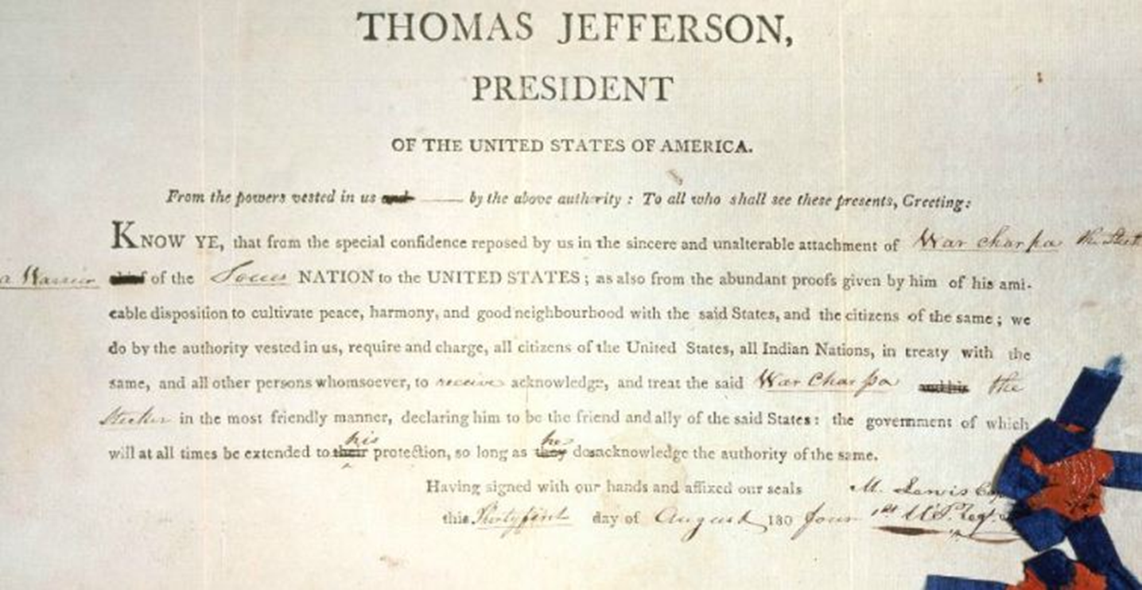

THOMAS JEFFERSON
PRESIDENT OF THE UNITED STATES OF AMERICA
From the powers vested in us and by the above authority: To all who shall see these presents, Greeting: Know ye, that from the special confidence reposed by us in the sincere and unalterable attachment of chief of the ______________NATION to the UNITED STATES; as also from the abundant proofs given by him of his amiable disposition to cultivate peace, harmony, and good neighborhood with the said States and the citizen of the same, we do, by the authority vested in us, require and charge all citizens of the United States, all Indian Nations, in treaty with the same and all other persons whomsoever to receive, acknowledge and treat the said__________and his ________________in the most friendly manner, declaring him to be the friend and ally of the said States: the government of which will at times be extended to his protections, so long as he does acknowledge the authority of the same." Having signed with our hands and affixed our seals This________day of _________180____

Continue on back

