Election of 1800
Political Cartoon/propaganda

Propaganda-
Ideas or information designed and spread to influence public opinion.

Your Task:
Create 2 campaign posters/political cartoons for your candidate (John Adams or Thomas Jefferson)

The first poster should communicate some positive aspect of your candidate- Something about his qualifications, his stance on an issue, or one of his specific actions or ideas that would appeal to voters. The goal of this poster is to convince voters that your candidate is the right choice for President.

The second poster should draw attention to some negative aspect of your opponent- Something about his background, his stance on an issue, or one of his specific actions or ideas that would make him look bad. The goal of this poster is to convince voters that your opponent is the wrong choice for President.

Page 2: Sample poster format
Page 3: Poster directions/guidelines

CONTINUE

Sample Poster Format:

Title/Slogan

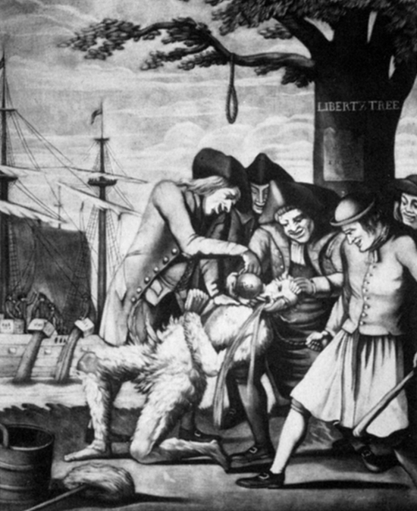
Cartoon

Caption or brief explanation

Directions/Guidelines for the political cartoon/posters on next page

Directions/Guidelines for the political poster/cartoon:
3 points= all directions followed and guidelines met
2 points= most directions followed and guidelines met
1 point = a number of guidelines not met/directions not followed

- Slogan/Title (3 points)
  - Include a title or slogan (at the top) that illustrates a positive aspect of your candidate or his views, or a negative aspect of your opponent and his views.
  - The title/slogan must match the main idea of the cartoon you will draw
  - Limit your slogan to a single phrase- no more than a sentence long.
  - Your title/slogan should be easily understood by your classmates & not need explanation.

- Cartoon (3 points)
  - Draw a political cartoon that your classmates will be able to interpret and understand.
  - The cartoon must be based on one of the issues, events, or ideas we have discussed in class where there is a difference between the Federalists (John Adams) and the Democratic-Republicans (Thomas Jefferson). See the “Debate Issues and Questions” Assignment in the handouts section of your notebook to help you choose.
  - The cartoon must include details that illustrate why your candidate is a good choice, or why your opponent is a bad choice for President
  - You may include word bubbles, and you may label people in your cartoon.

- Caption (3 points)
  - Include a short caption (at the bottom) that helps explains the cartoon.
  - This should be no more than a couple of sentences long. Keep it brief, you’re not writing an essay here.

*Use the paper provided by Mr. O’Mara

